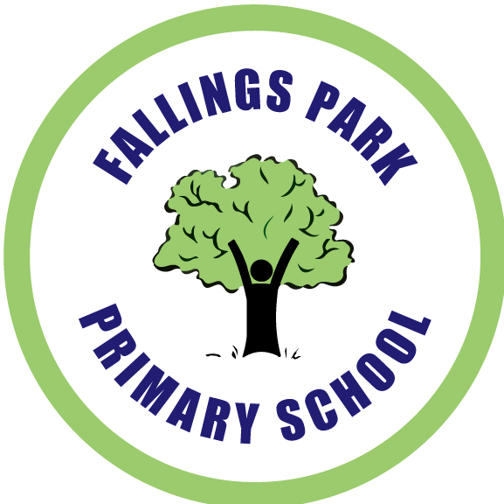 | Fallings Park Primary School  Old Fallings Lane  Wolverhampton  WV10 8BN  Tel: 01902 558375  Fax: 01902 558376  fallingsparkprimary@wolverhampton.gov.uk  Thursday 5th December 2019

Dear Parent/Carer,

Re: Year 6 – West Midlands Fire Service ‘Safeside’ in Birmingham.

As part of our curriculum this term, a visit has been planned. Details of the visit are outlined below:

When: Thursday 23rd January 2020

Where: Safeside in Birmingham

Depart: 8:45am Return: 4:00pm

Lunch arrangements: Pupils will require a packed lunch for the day. These can be provided by our school caterers ‘Shire Services’ at a cost of £2.30 (free of charge if your child is eligible for free school meals) or if you wish for your child to bring their own packed lunch please inform school on the consent form attached.

Uniform: School Uniform to be worn.

Your child will also need: Uniform to be worn with a warm waterproof coat and sensible footwear.

Whilst curriculum visits are subsidised, a voluntary contribution of £3.90 is suggested in order for the school to provide this visit.

Please sign and return the permission slip attached by Friday 10th January 2020.

Payments can be made via your Parent Pay account or alternatively if you have opted to pay via Paypoint, you can pay in cash at your local store. Just produce the individually bar coded letter that your child received via their class teacher, this will then be scanned and payment credited to your account.

Yours sincerely

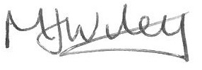

M Wiley
Assistant Head Teacher, Key Stage 2

Year 6 Visit – Safeside Visit

I give permission for my child ____________________________________

Class _______________

To attend the visit to ‘Safeside’ Birmingham.

I will pay £3.90 as a voluntary contribution through Parent Pay.

Signed Parent/Carer _________________________________

Name of Parent/Carer _________________________________

Visit Lunch Arrangements

ALL MEAL ORDERS MUST BE RECEIVED BY FRIDAY 10th JANUARY 2020

I would like to receive a school packed lunch (please choose a sandwich filling below)

- Cheese
- Ham
- Tuna
- Chicken
- Egg and Cress

Your child will also receive a freshly made cookie or cupcake, a piece of fruit, crisps and a drink.

My child will bring their own packed lunch □
(no glass bottles or fizzy drinks allowed)

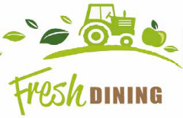

Office Use Only
Name | Class | Date of Visit | Eligible for FSM
 |  | 23.10.2020

