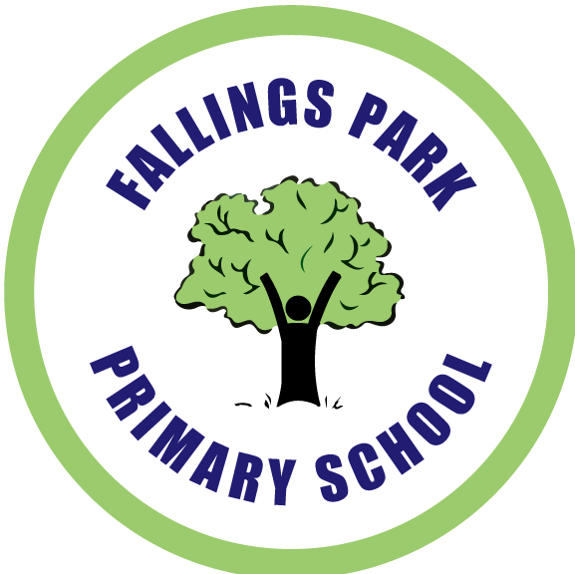 | Fallings Park Primary School  Old Fallings Lane  Wolverhampton  WV10 8BN  Tel: 01902 558375  Fax: 01902 558376  fallingsparkprimary@wolverhampton.gov.uk  1st October 2019

Dear Parent/Carer

Re: Tiny Trees Visit – Santa Safari

As part of our curriculum this term, a visit has been planned for Tiny Trees to visit the Santa Safari event at West Midland Safari Park on Friday 6th December.

Children will get the opportunity to meet Santa and his elves and then select a gift from the elves workshop.

Please note a parent/carer must accompany Tiny Trees students on this visit. Therefore the cost of the visit is for one adult and one child. Whilst curriculum visits are subsidised, a voluntary contribution of £20.00 is suggested in order for the school to provide this visit. If we do not receive enough contributions the visit may have to be cancelled.

The coach will be leaving school at 9.15am and returning for approximately 3pm.

Lunch arrangements: Please send your child with a packed lunch in a disposable carrier bag. No fizzy drinks or glass bottles.

Uniform: School t-shirt and jumper to be worn with jeans or jogging suit bottoms.

Your child will also need: warm waterproof jacket and sensible shoes.

Please sign and return the permission slip attached.

Payments can be made via your Parent Pay account or alternatively if you have opted to pay via Paypoint, you can pay in cash at your local store. Just produce the individually bar coded letter that your child received via their class teacher, this will then be scanned and payment credited to your account.

Yours Sincerely

Mrs J Ebblewhite
Assistant Head Teacher – Early Years

Tiny Trees – Safari Park

I give permission for my child ____________________________________

Class _______________

To attend the visit to Santa Safari at West Midland Safari Park.

I will pay £20 as a voluntary contribution through Parent Pay.

Signed Parent/Carer _________________________________

Name of Parent/Carer _________________________________

