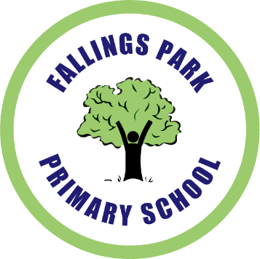
Fallings Park Primary School
Old Fallings Lane
Wolverhampton
WV10 8BN
Tel:01902 558375
Fax: 01902 558376

2nd March 2020
Reception Learn Together Session
Mothering Sunday

Dear Parents,

I am writing to share with you our improved arrangements for the sharing children’s learning.

- Do you come to curriculum assemblies and think “I’d like to see more of what my child can do?”
- Are you stuck at the back of the hall, straining to see your child in the distance?
- Is your child in the back row, stood behind the tallest child in the year group?
- Does your child not have a large enough contribution to the assembly?

If you have answered “Yes!” to one or more of these questions, then worry no more!

In this coming academic year you are invited to a class session in our parent partnership building where:

- You will be able to see your child work and learn.
- You will work alongside your child, learning with them.
- You can enjoy a cup of tea or coffee.

The session will be held on:

RLG – Wednesday 18th March 2:15pm
RCD – Thursday 19th March 2:15pm
RHE – Friday 20th March 2:15pm

Entry to school will be through Parent Enquiries.

Yours sincerely,

Mr Hopkins

_ _ _ _ _ _ _ _ _ _ _ _ _ _ _ _ _ _ _ _ _ _ _ _ _ _ _ _ _ _ _ _ _ _ _ _ _ _ _ _ _ _ _ _ _ _ _ _ _

Childs Name: ………………………………………………………………………………

The following adults will be attending the Reception Learn Together Session.

…………………………………………………………………………………………………

…………………………………………………………………………………………………

Signed………………………………………….. (Parent /guardian)

