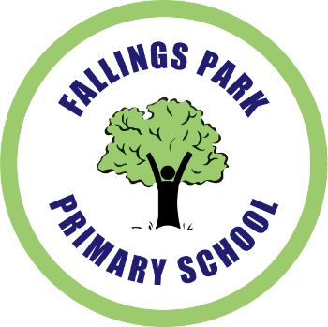

Job Opportunities at Fallings Park

We are seeking

- A Lunchtime Supervisory Assistant commencing as soon as possible in Spring Term 2020

Scale: Grade 2 Point 2 Term time Monday to Friday
Start time: 11:55am Finish time: 1:40pm (8.75 hours per week)

Applicants should email the school office for an application form and job spec.

This post is subject to:

- an Enhanced Disclosures and Barring Service Check and requires compliance with all associated policy.
- a six month probationary period with reviews at one months and three months.

Deadline: 3:00pm Monday 24th February 2020 with interviews to follow the same week

Job Opportunities at Fallings Park

We are seeking

- A Lunchtime Supervisory Assistant commencing as soon as possible in Spring Term 2020

Scale: Grade 2 Point 2 Term time Monday to Friday
Start time: 11:55am Finish time: 1:40pm (8.75 hours per week)

Applicants should email the school office for an application form and job spec.

This post is subject to:

- an Enhanced Disclosures and Barring Service Check and requires compliance with all associated policy.
- a six month probationary period with reviews at one months and three months.

Deadline: 3:00pm Monday 24th February 2020 with interviews to follow the same week

